Nepal College of Information Technology
Balkumari Lalitpur
Assessment Exam Fall Semester 2008
Year: I Sem: I
Program: B.E Time: 3hrs
FM: 100 PM: 50

Engineering Math-I

1. a. Check the continuity and differentiability of the function 8
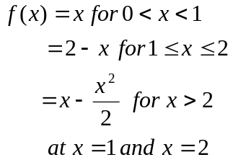
OR
If y = 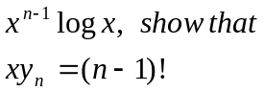
b. State and prove Lagrange's mean value theorem, give its geometrical interpretation. 7
2. a) Evaluate 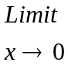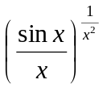 7
b) Find the surface area of the right circular cylinder of greatest surface, which can be inscribed in sphere of radius r. 8
3. Integrate (Any three) 3*5
a) 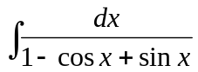
b) 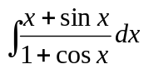
c) 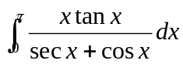
d) 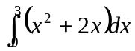by summation method
4. a) Find the area bounded on the left by the parabola x = y², on the right by the line y = x -2 and below by the x - axis. 7
OR
Find the volume of solid in the region in the first quadrant evolved by the parabola y = x², the y-axis and the line y = 1 revolved about the line x = .
b) Evaluate 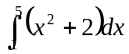 by using Trapezoid rule, Simpson's rule and compare the result with exact value taking n = 4. 8
5. a) Derive a condition that the line lx + my +n = 0 touches the parabola y² = 4ax 7
b) Derive the standard equation of the ellipse 8
6. a) Find the equation for the plane through (2,4,10) and perpendicular to the line
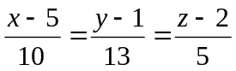 7
b) Define scaler triple product, give its geometrical meaning and prove 8
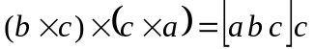
7. Attempt any five 2*5
a) Find the domain and range of y = 1 + 
b) Evaluate
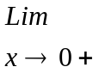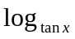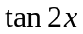
c) Find vertex, focus & directix of the parabola
x² +8y - 2x -17 = 0
d) Integrate 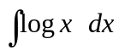
e) Find the length of the curve y = 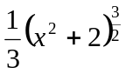 from x = 0 to x = 3
f) Find equation of line through (2,4,5) and perpendicular the plane 3x + 7y - 5z = 100

